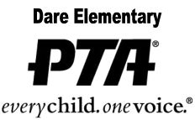

PTA Meeting
September 26, 2017
- Call to order
Sabrina Brown, president, called to order the general membership meeting of the Dare Elementary School PTA at 5:40 pm on September 26, 2017 at the DES Cafeteria.
- Attendance
Leslie Hautz, Secretary. Please see attached
- New Business
Sabrina Brown and Deb Metcalf presented the proposed budget for the 2017-2018 school year. Budget was approved by vote of general membership.
- Adjournment
Sabrina Brown, president, adjourned the meeting at 5:45 pm.

Minutes submitted by:
Minutes approved:
As Written: __________
As Amended: _________
Date: ________________________

Attendance

- Sabrina Brown
- Kristina Byrum
- Angie Zabicki
- Leslie Hautz
- Rachel Minor
- Amber Weaver
- Deb Metcalf
- Mandy Hunt
- Lindsey Cacavale
- Lindsey Blackmon

