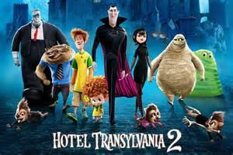
Dare Family Movie Night

Please join us at Dare Elementary for the Dare PTA Family Movie Night on Thursday, February 11 from 6:00-8:00pm to watch Hotel Transylvania 2. Included in the ticket price is the movie and dinner - pizza, salad, drink and popcorn for $5.00 (additional slices of pizza and drinks may be purchased). Candy will also be available for purchase. Please return the bottom portion in an envelope marked Movie Night along with cash or check made out to Dare Elementary PTA by Wednesday, February 10th.

Tickets will be sent home with your child on Thursday, February 11 or can be picked up at the door if your child leaves them at school. A limited amount of additional tickets will be available for sale Thursday night. We cannot guarantee pizza/drinks to families that purchase tickets on Movie Night so please try to reserve your tickets ahead of time. A parent/guardian must accompany children to Movie Night. If you have any questions, please contact Allison Lucas (757) 833-6541 (allison.lucas99@hotmail.com) or Debbie Williams (757) 570-8383 (tagalongwife@verizon.net).

Feel free to bring blankets or pillows to make yourselves comfortable!

------------------------------------------------------------------------------------------------------------------------------------------

Number Attending:x $5.00 = $ ____ Student(s) Name:____________________
_____________________

Teacher’s Name: ___________________ Room #:______
*if you have more than one child attending, please indicate which room you would like your family’s tickets to be delivered to

Parent(s)/Guardian(s) Name: ________________________________________
Contact #/email: ___________________________________________________

Yes, I would like to volunteer to help out at Movie Night! ______

