**PTA President:** Sabrina Brown **Vice President:** Kristina Byrum

**Treasurer:** Deb Metcalf **Secretary:** Leslie Hautz

# **Dare PTA February Newsletter**

**Updates**

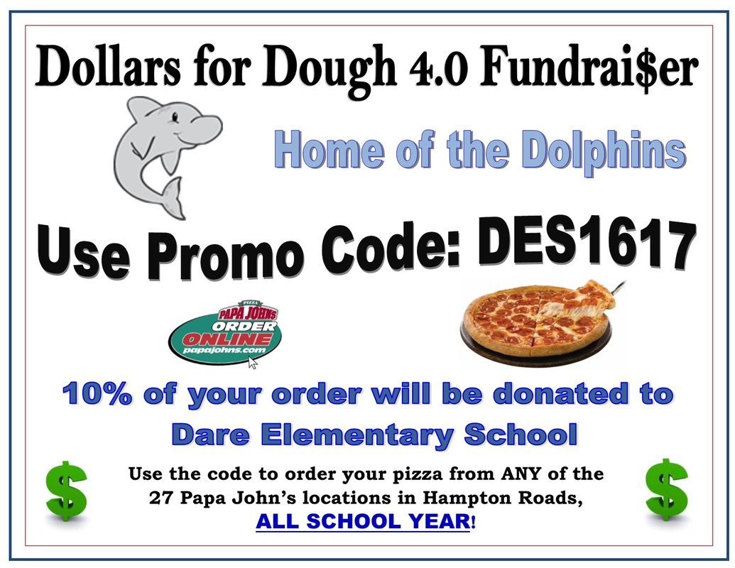

**1)** We will hold another Box Tops Collection Contest during March. Stay tuned for details!

**2)** Hospitality: Valentine’s Day Breakfast will be provided to teachers/staff. Sign-up genius was posted. If you didn’t get an email to sign up and you’d like to help in the future, you can contact Angie Zabicki at yorkmomma@icloud.com

**3)** Membership: Class membership contests will begin in February. Any class with 100% membership will receive a recess party!

4) Reflections: There were 18 submissions for the Reflections contest. Local Awards were presented. 1st place winners were forwarded to the County, where three of our students placed! Anna Zimeras’ entry will move on to District.

5) Cut and Paste will continue to meet Tuesday Mornings.

6) Virginia Lottery is sponsoring an art contest. Submission forms are on the counter in the office.

February

7th- Watch D.O.G.S. Event, 6-7 pm

13th- PTA Meeting, 6 pm

16th- Valentine’s Teacher Breakfast, 8 am

19th- Presidents’ Day, SNOW MAKE UP

22nd- Movie Night! 6:00pm

March

13th- PTA Meeting, 6 pm

14th- Papa John’s Teacher Delivery Night

15th-23rd- Book Fair

16th- Staff Hospitality Event

23rd- Dance of the Decades, 6-8 pm

**Upcoming Events!**

**PTA**

**Board**

**Nominating Committee:**

To elect the new PTA board for next year, a committee needs to be formed in March. Anyone interested please contact Sabrina Brown. We are also recruiting new people to chair committees. If you would like to be involved in heading up some of our family friendly events or committees, there are many opportunities! We are encouraging members to work together as co-chairs. So pick a fellow parent and attend our next PTA meeting to see how you can help! ☺

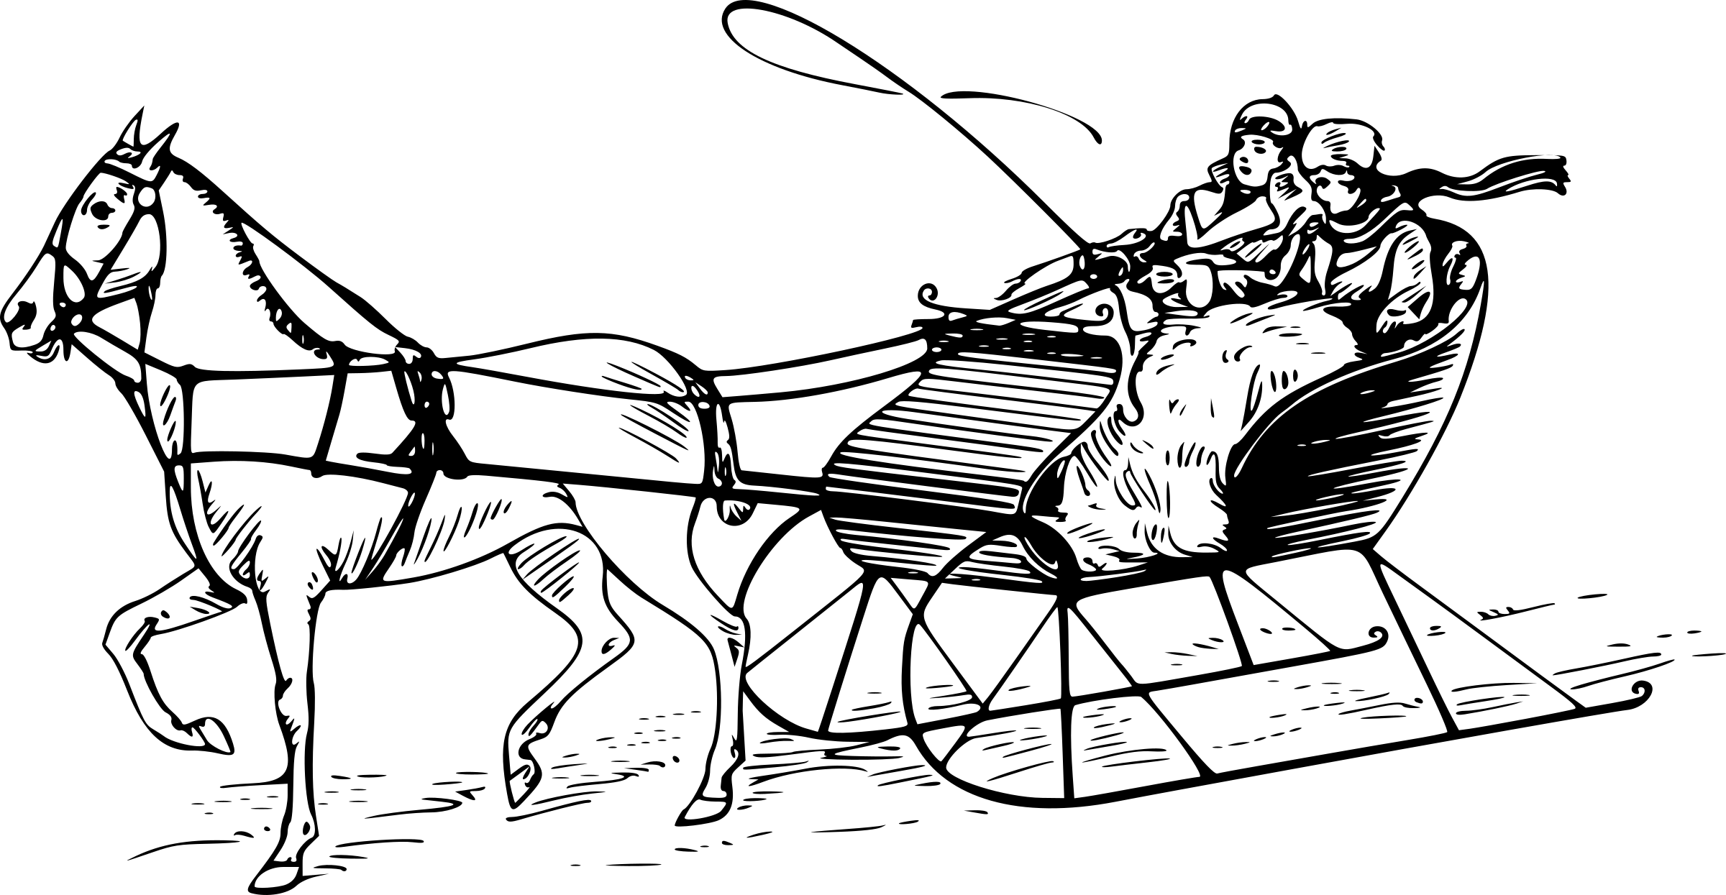

Over the river and through the woods to **KROGER** here we go!! Why are we on our way to **Kroger?** To earn Community Rewards for our school through our purchases! All you have to do is log in to your Kroger account and designate Dare Elementary 85336 to receive Community Rewards. Every time you swipe your Kroger Plus Card, Dare will receive rewards along with you. Don’t have a card? It’s free at the register or Customer Service area. So **TALLY HO**!! The sooner you begin this program the better!

**Kroger Rewards!**